**Ideation Phase**

**Define the Problem Statements**

|  |  |
| --- | --- |
| Date | 19 September 2022 |
| Team ID | PNT2022TMID45109 |
| Project Name | Project – News Tracker Application |
| Maximum Marks | 2 Marks |

**Customer Problem Statement Template:**

Create a problem statement to understand your customer's point of view. The Customer Problem Statement template helps you focus on what matters to create experiences people will love.

A well-articulated customer problem statement allows you and your team to find the ideal solution for the challenges your customers face. Throughout the process, you’ll also be able to empathize with your customers, which helps you better understand how they perceive your product or service.

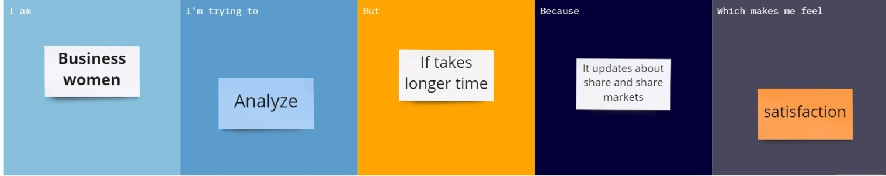

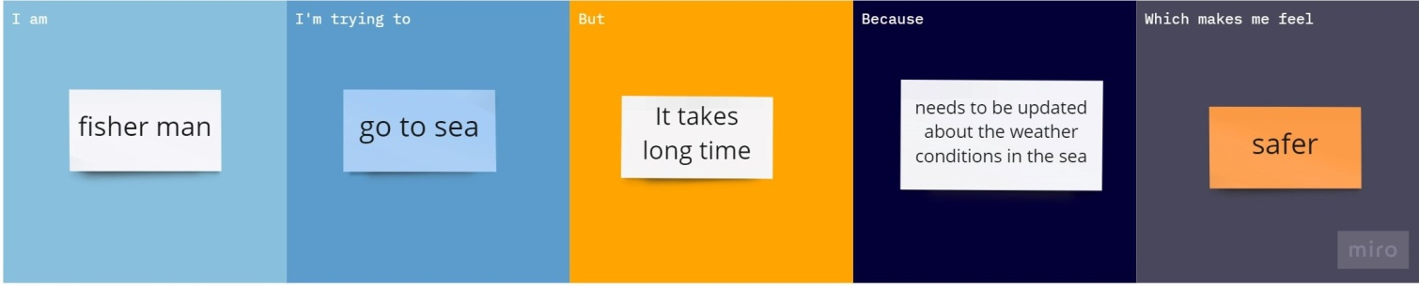

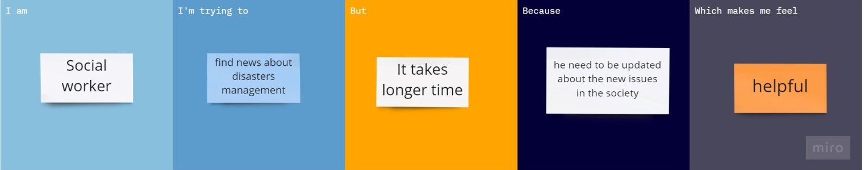

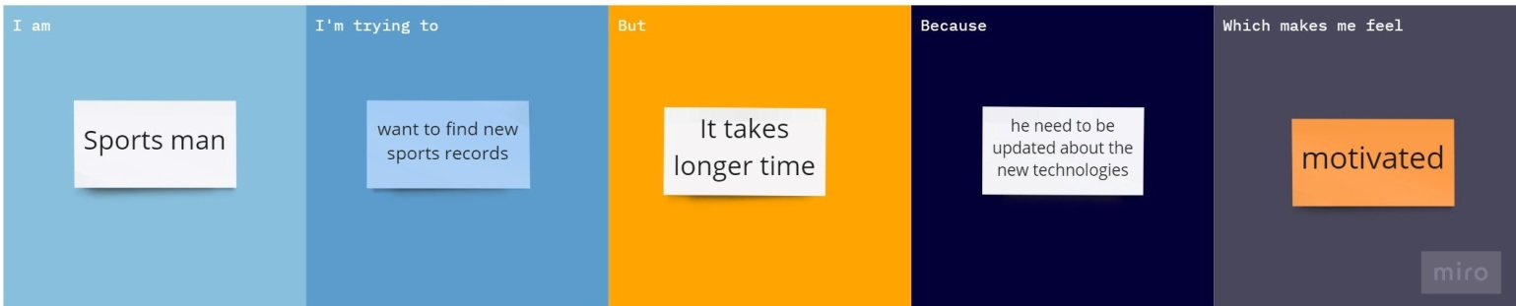

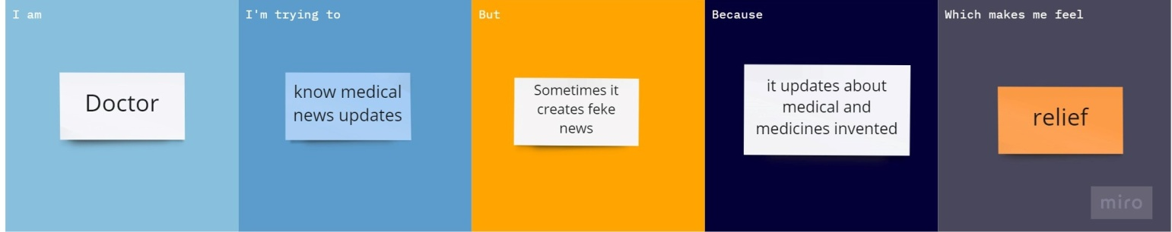

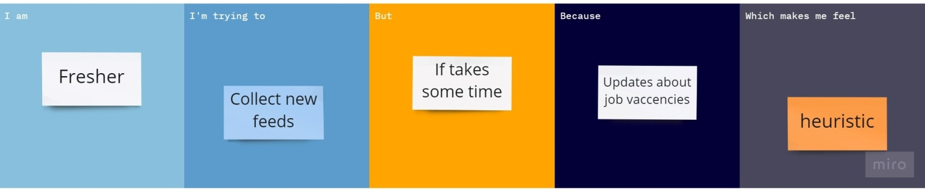

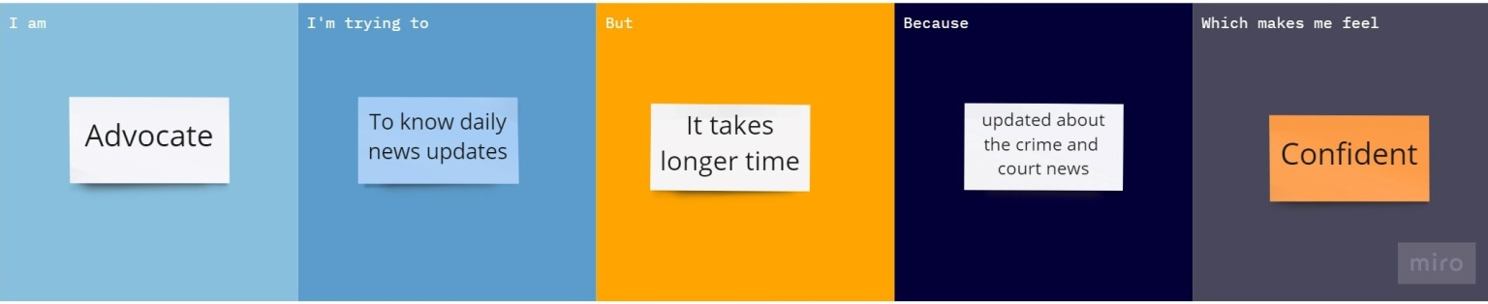

|  |  |  |  |  |  |
| --- | --- | --- | --- | --- | --- |
| **Problem Statement (PS)** | **Iam (Customer)** | **I’m trying to** | **But** | **Because** | **Which makes me feel** |
| PS-1 | BUSINESS MAN | Analyse news | It takes me long time | Updates about share market | Satisfied |
| PS-2 | FISHERMAN | To go fishing in sea | It takes me long time | It updates  about medical and invented medicine | Relief |
| PS-3 | SOCIAL WORKER | To find disasters | It takes me long time | Updated about issue in society | Helpful |
| PS-4 | SPORTSMAN | New sports record | It takes me long time | Need to be updated about trending | Motivated |
| PS-5 | DOCTOR | Know medical news updates | It takes me long time | It updates  about medical and invented medicine | Relief |
| PS-6 | FRESHER | Collect new feeds | It takes me long time | Know about job vacancies | Heuristic |
| PS-7 | ADVOCATE | Daily updates | It takes me long time | Updated  about weather conditions | Confident |